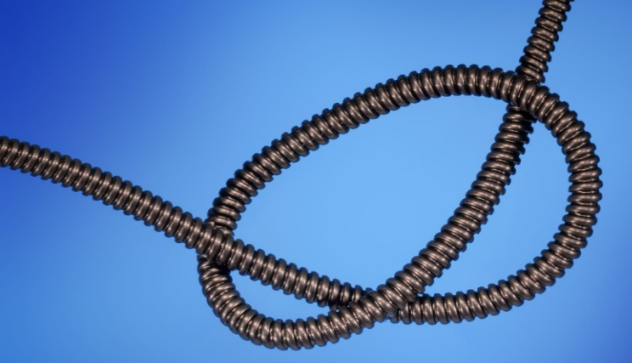
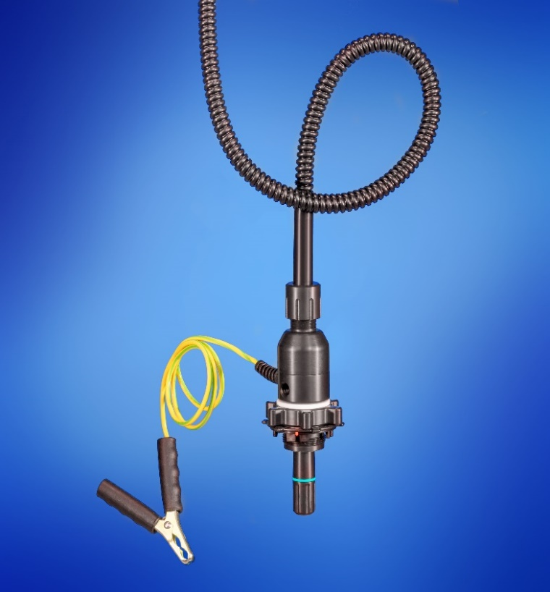
Technical Data

 |  | PFA
Ø Outside | Ø Inner | Wall Thickness | Working Pressure | Brust  Pressure
Inch | mm | mm | bar | bar
1/2“ | 9,50 | 1,60 | 7 | 25
3/4" | 15,80 | 1,60 | 4,5 | 10

Bending radius | 1/2" | 15,00
mm | 3/4" | 20,00

Co-extruded Corrugated tubing with antistatic outer layer enable ultra-flexible handling of the QC-System. Ideal for vertical and horizontal installation of the suction line.

Properties:

- More stable compared to usual corrugated PFA tubing due to inwards corrugation
- Conductive Flare connections on both ends tube
- 10cm-long straight hose ends on both sides so that the QC Dispense Head can easily be connected with the flare connecting system

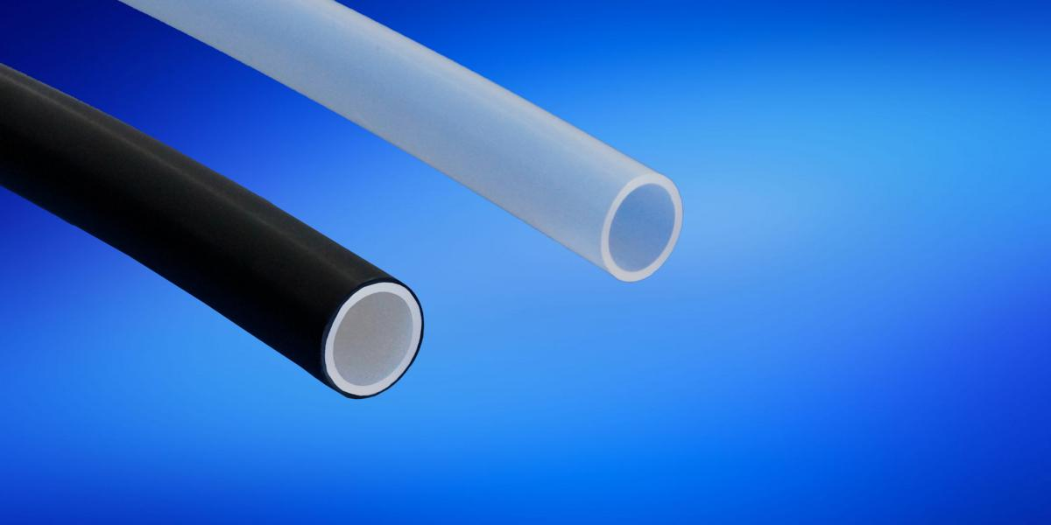
Technical Specifications

Material | - Inside virgin PFA  - Outside antistatic PFA
Nominal widths | - 1/2"  - 3/4“  *more available on request
Max Length | - 1/2" up to 4,5 meters  - 3/4" up to 6 meters
Working Temperature | - Up to 60°C
End Connections | - 10 cm-long straight hose ends on both sides
*incl. Flare nuts CD/PVDF on both sides
Standard Versions

Size in Inch | Usability length in mm* | Item-no.
1/2" | 1000 | R12S121-CD-CT-1-230-FL
1/2" | 2000 | R12S121-CD-CT-2-230-FL
3/4“ | 2000 | R12S122-CD-CT-2-230-FL
3/4" | 3000 | R12S122-CD-CT-3-230-FL

